Reliability of photovoltaic panels for agrivoltaic systems

Kozelka M., Zholobov M., Poulek V., Libra M.
Faculty of Engineering, Czech University of Life Sciences Prague
Kamýcká 129, 16500 Prague, Czech Republic

Corresponding author: Kozelka M., e-mail: kozelka@tf.czu.cz
Keywords: photovoltaics, agrivoltaics, PV panels, service expenses

A majority of PV panel producers declare a PV panel lifetime round 25 years. But our data evaluation from long-term monitoring of many PV power plants show, that PV panels start to fail after about 10-12 years. Compared to standard PV systems, the agrivoltaic systems are exposed to extraordinary influences of agriculture like dust, humidity, vibrations, fertilizers etc. Our studies compare the quality of PV panel components within last 25 years. We performed long-term monitoring of 85 PV power plants, including agrivoltaics in the Czech Republic and in abroad. PV panel failures within strings cause subsequent damage to multistring inverters. The total expenses for PV panel and PV inverter replacement are growing quickly after 10-12 years of the PV power plant operation. Hence, it is very important to study the reliability characteristics of PV panels to predict their real lifetime and to predict PV power plant service expenses.
During the last 15 years, the price of PV panels has decreased by about 15 times. Mass production has certainly contributed to this, but the main reason was the use of cheaper and lower quality materials and more economical construction. This ultimately had to reduce the real lifetime of PV panels. For example, cheaper polymers degrade faster and let moisture through [1] (see fig. 1). Thinner frames cause more bending [2]. It is obvious that the lower lifetime of photovoltaic panels will cause lower profitability of the entire photovoltaic power plant (see fig. 2). The next step of the research will be focusing attention on all components of agrivoltaic power plants and assessing the overall reliability of the entire system.
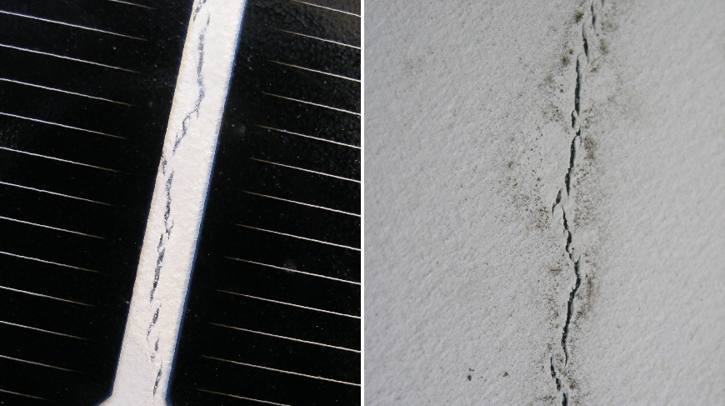
Fig. 1. Degradation of the polymer on the back side.
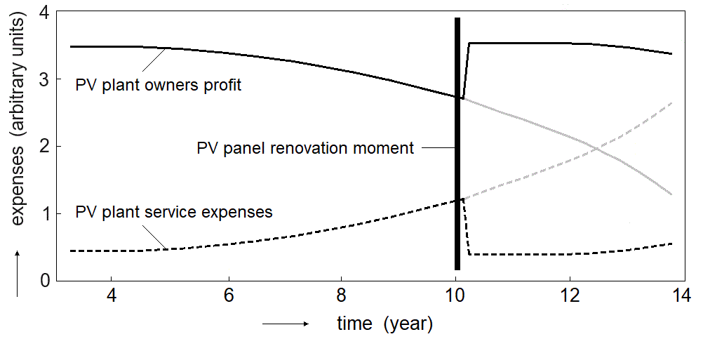
Fig. 2. Comparison between PV power plant owners’ profit and service expenses.

References:
- Omazic, A., Oreski, G., Halwachs, M., Eder, G.C., Hirschl, C., Neumaier, L., Pinter, G., Erceg, M., 2019. Relation between degradation of polymeric components in crystalline silicon PV module and climatic conditions: A literature review. Solar Energy Materials and Solar Cells, 192, 123-133.
- Poulek, V., Aleš, Z., Finsterle, T., Libra, M., Beránek, V., Severová, L., Belza, R., Mrázek, J., Kozelka, M., Svoboda, R., 2024. Reliability characteristics of first-tier photovoltaic panels for agrivoltaic systems – practical consequences. International Agrophysics, 38(4), 383-391.

