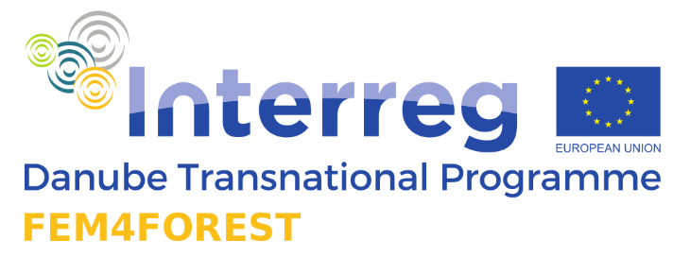

FORESTS IN WOMEN'S HANDS
The project Fem4Forest "Forests in Women's Hands" started in July 2020 and involves 14 partners from 10 countries (Slovenia, Croatia, Austria, Germany, Bosnia and Herzegovina, Serbia, Romania, Czech Republic, Bulgaria, Ukraine). The project is funded under the Interreg Danube Transnational Program. The leading partner is the Forestry Institute of Slovenia, and the project leader is dr. Nike Krajnc.
In the Czech Republic, around 40 % of forest owners are women. At the Faculty of Forestry and Wood Sciences of the Czech University of Life Sciences, 34,4 % of faculty alumni are women.
Within the Fem4Forest project, we will highlight different roles of women in forestry and more broadly, in forest supply chains. We will explore different possibilities for more active participation of women in forest management as well as in the labour market and in different levels of decision-making. Through a series of pilot projects in the Danube region, we aim to identify different possibilities for a more active role of women through the transfer of ideas and examples of good practice.
The main objective of Fem4Forest is to strengthen the forest sector at local, regional and interregional level trough increased involvement and ability of women actors by supporting their equal presence and competences at the market in Danube region. The project offers a new and innovative approach to education and mentoring that will enable a more active role for women in the forestry sector.
On the basis of a comparative study and a selection of examples of good practice, we will present various employment opportunities for women in forestry in the participating countries. The planned activities are demand-driven and target three most crucial components: social inclusion, gender equality and economic independency. Due to multi-actor approach Fem4Forest has the genuine and strong involvement of target groups that will be engaged in various activities in order to voice their needs and co-create good practice examples. Thus, the Fem4Forest model (demand-based action plan, awareness campaign, mentoring and training program) for the integration of women will be developed. By addressing the problem of young and long-term unemployed women in rural areas, we will also contribute to a higher employment level in the Danube region in the long term.

PROJECT ID:
TITLE: Gozdovi v ženskih rokah - Forests in women ‘s hands
Acronym: Fem4Forest
Project No.: DTP3-500-1.2 Fem4Forest
Start date: 1.07.2020 End date: 31.12.2022
Project budget: 1.6 million €
Partnership: 14 partners, from 10 countries (7 ERDF, 2 IPA, 1 ENI-UA)

